**Final project**

**Github repo URL :https://github.com/mani1010dev/finalrepo.git**

**deployed site URL: http://50.17.164.236:3000**

**docker images : react-app**

**Jenkins - login page**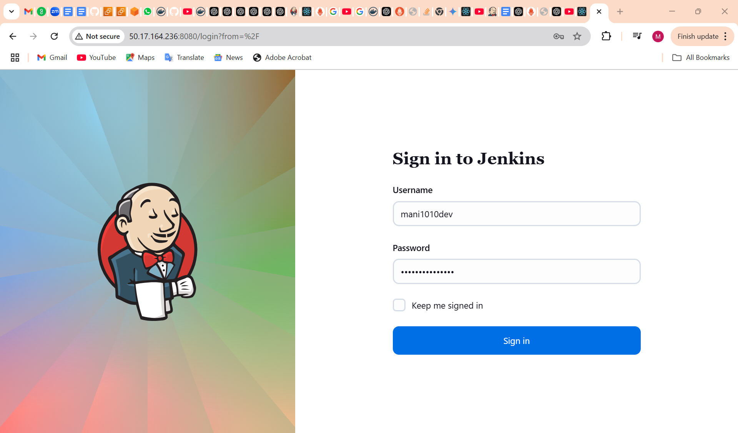

**configuration settings**

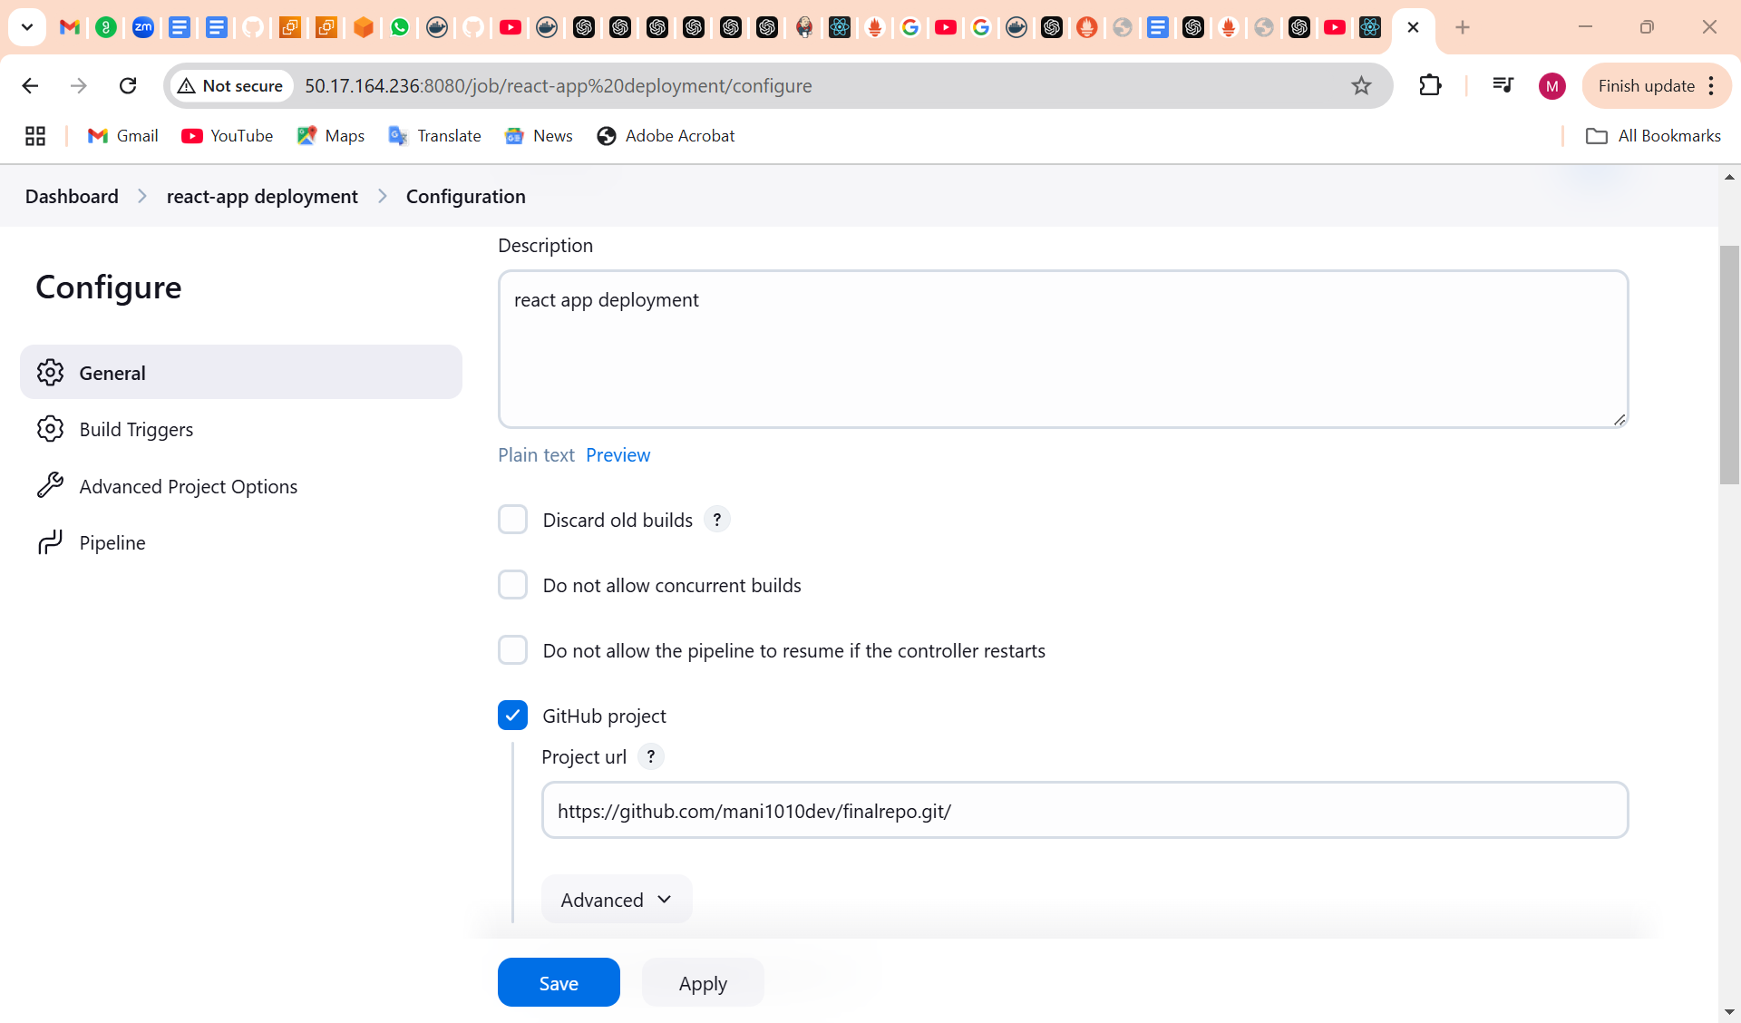

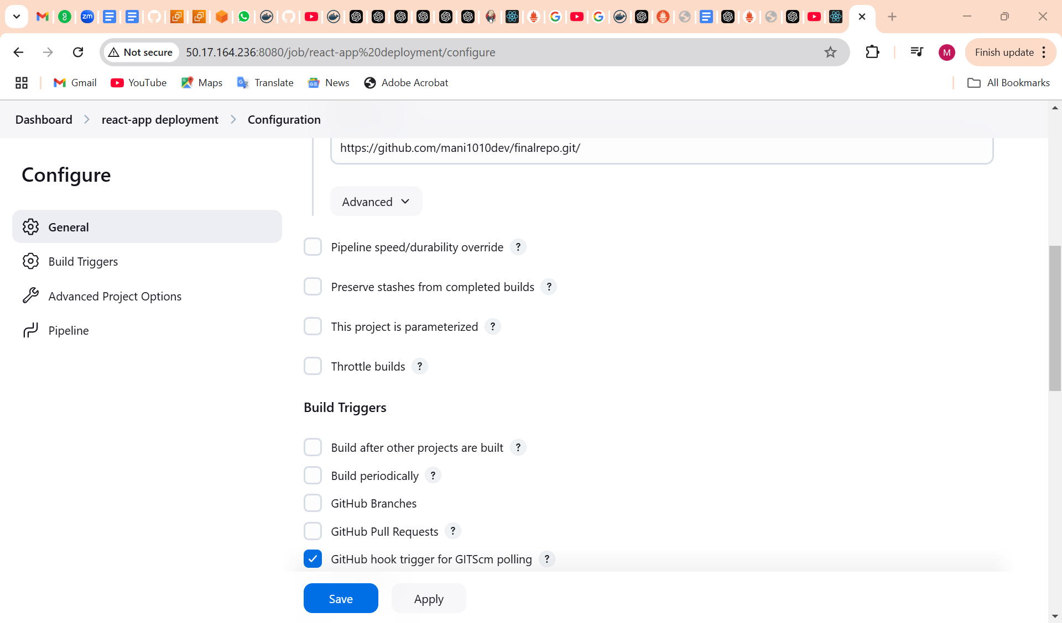

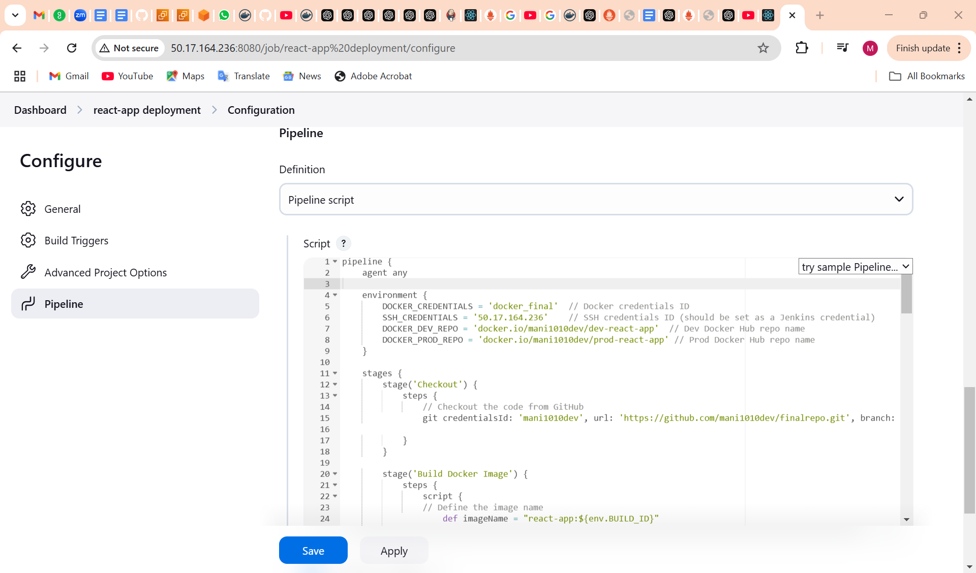

**execute step commands:**

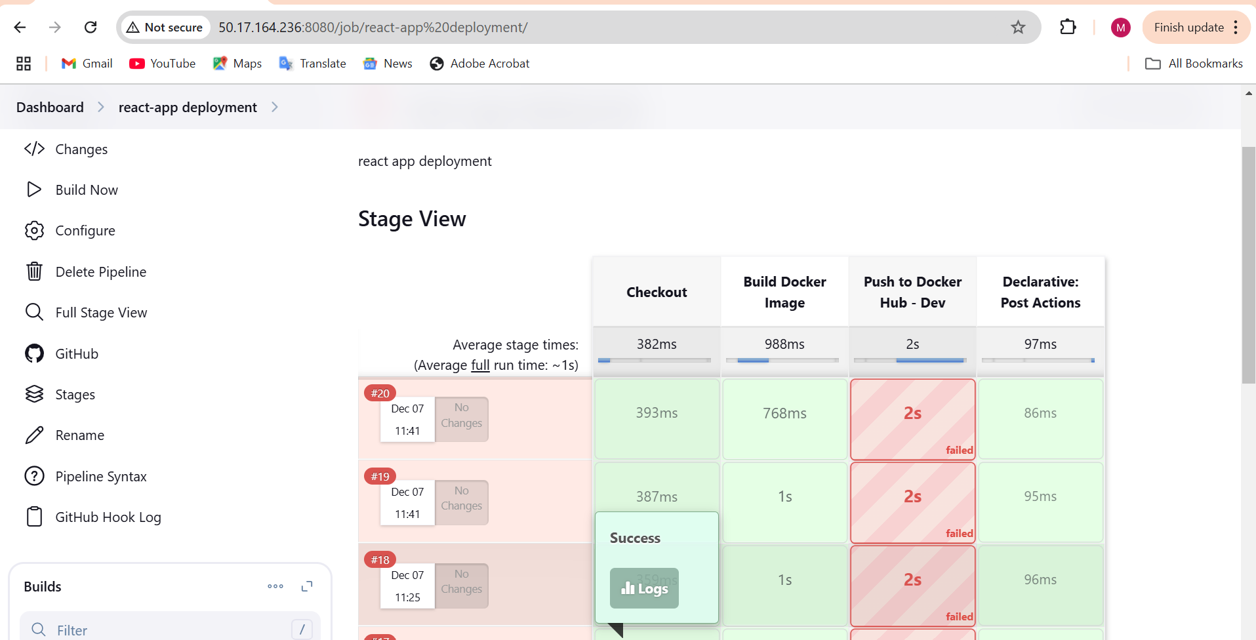

**AWS - EC2-Console**

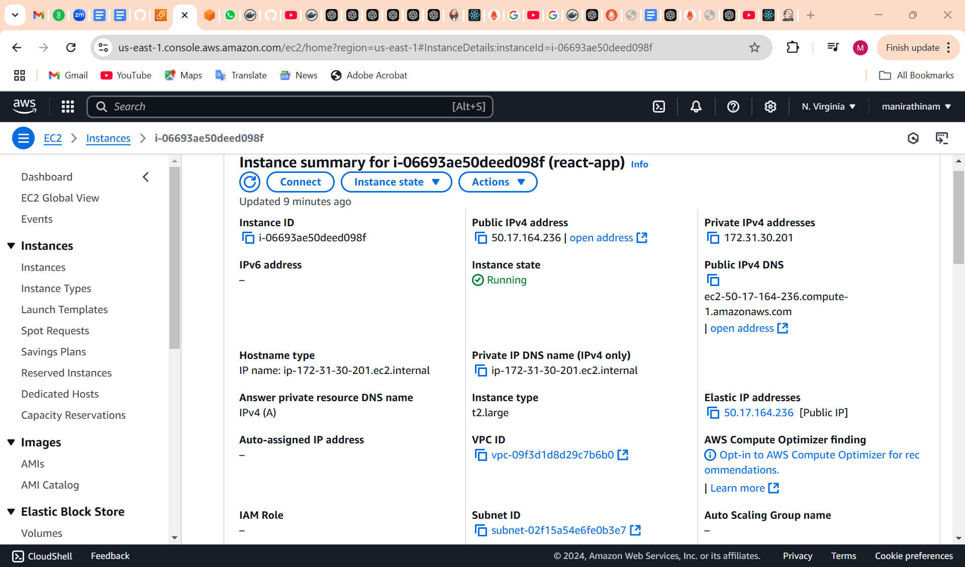

**SG - configs**

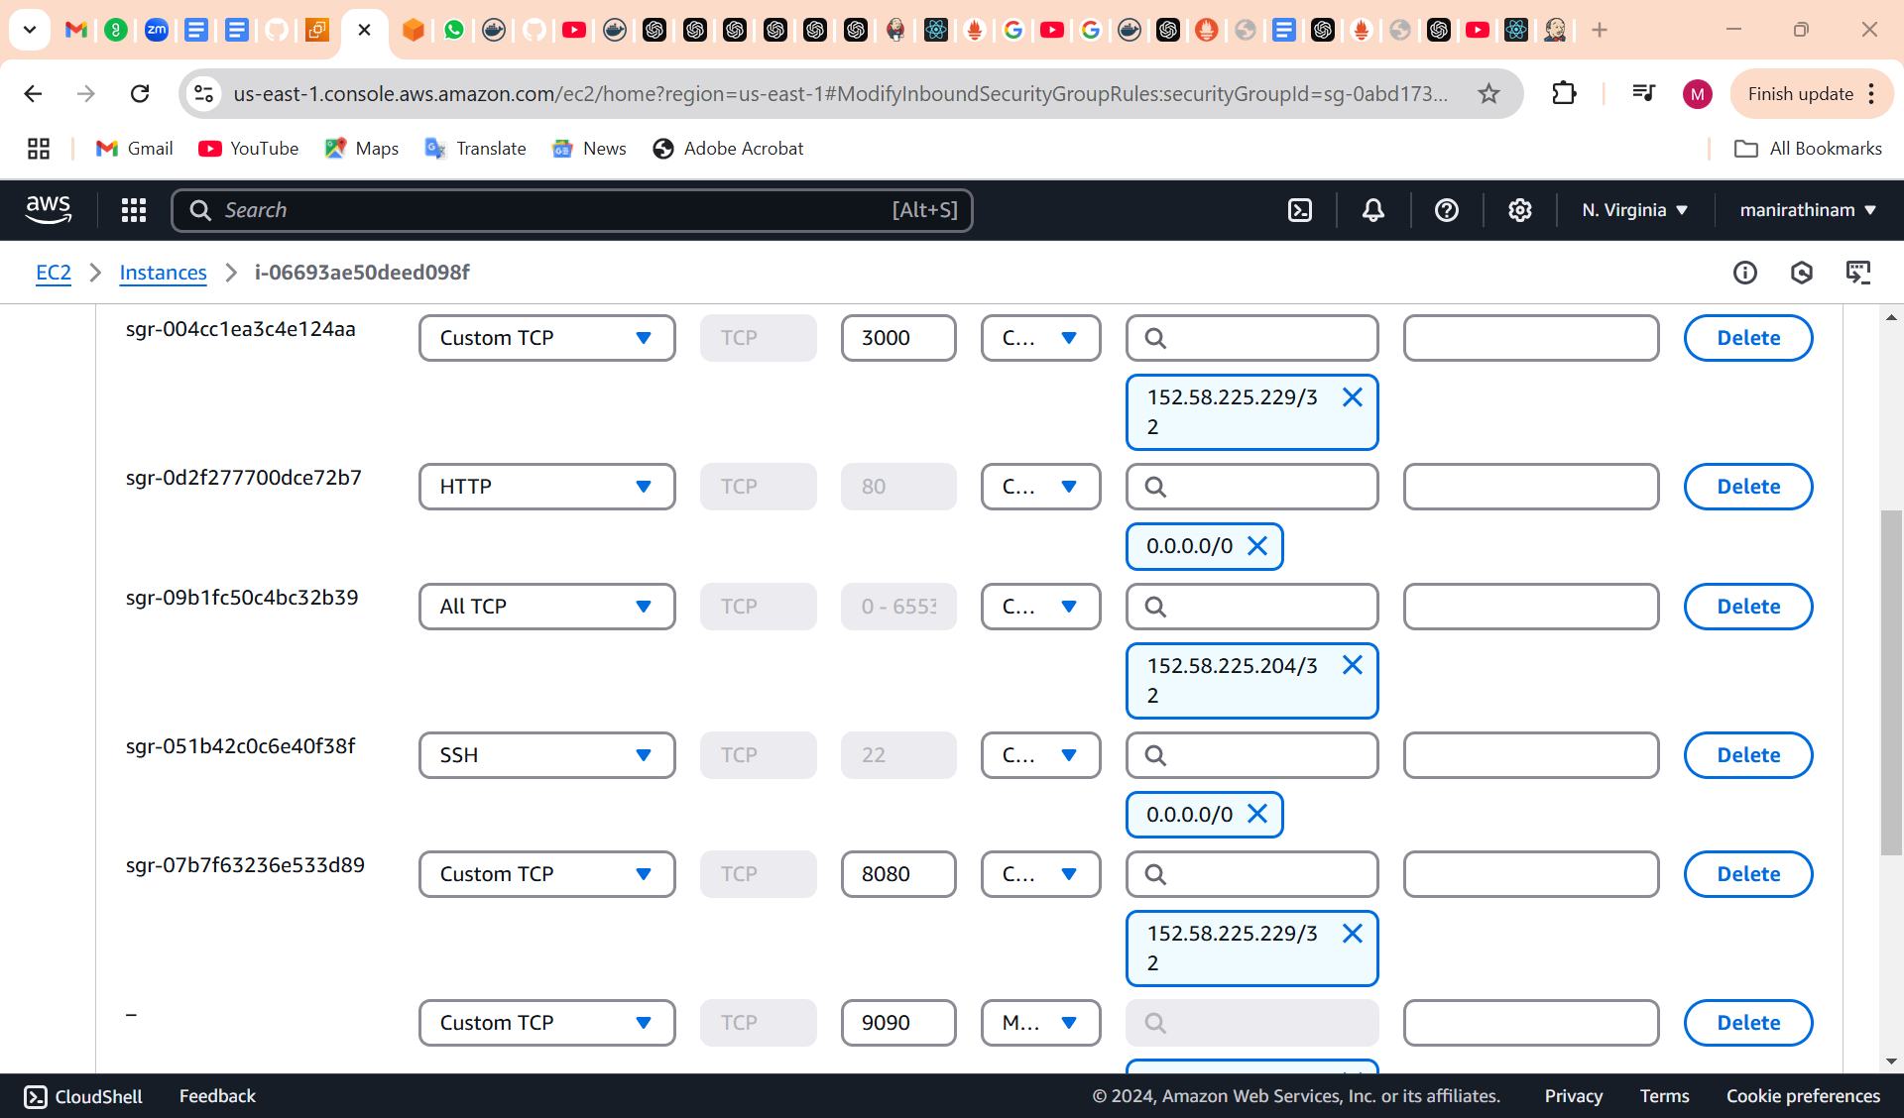

**Docker hub repo with image tags**

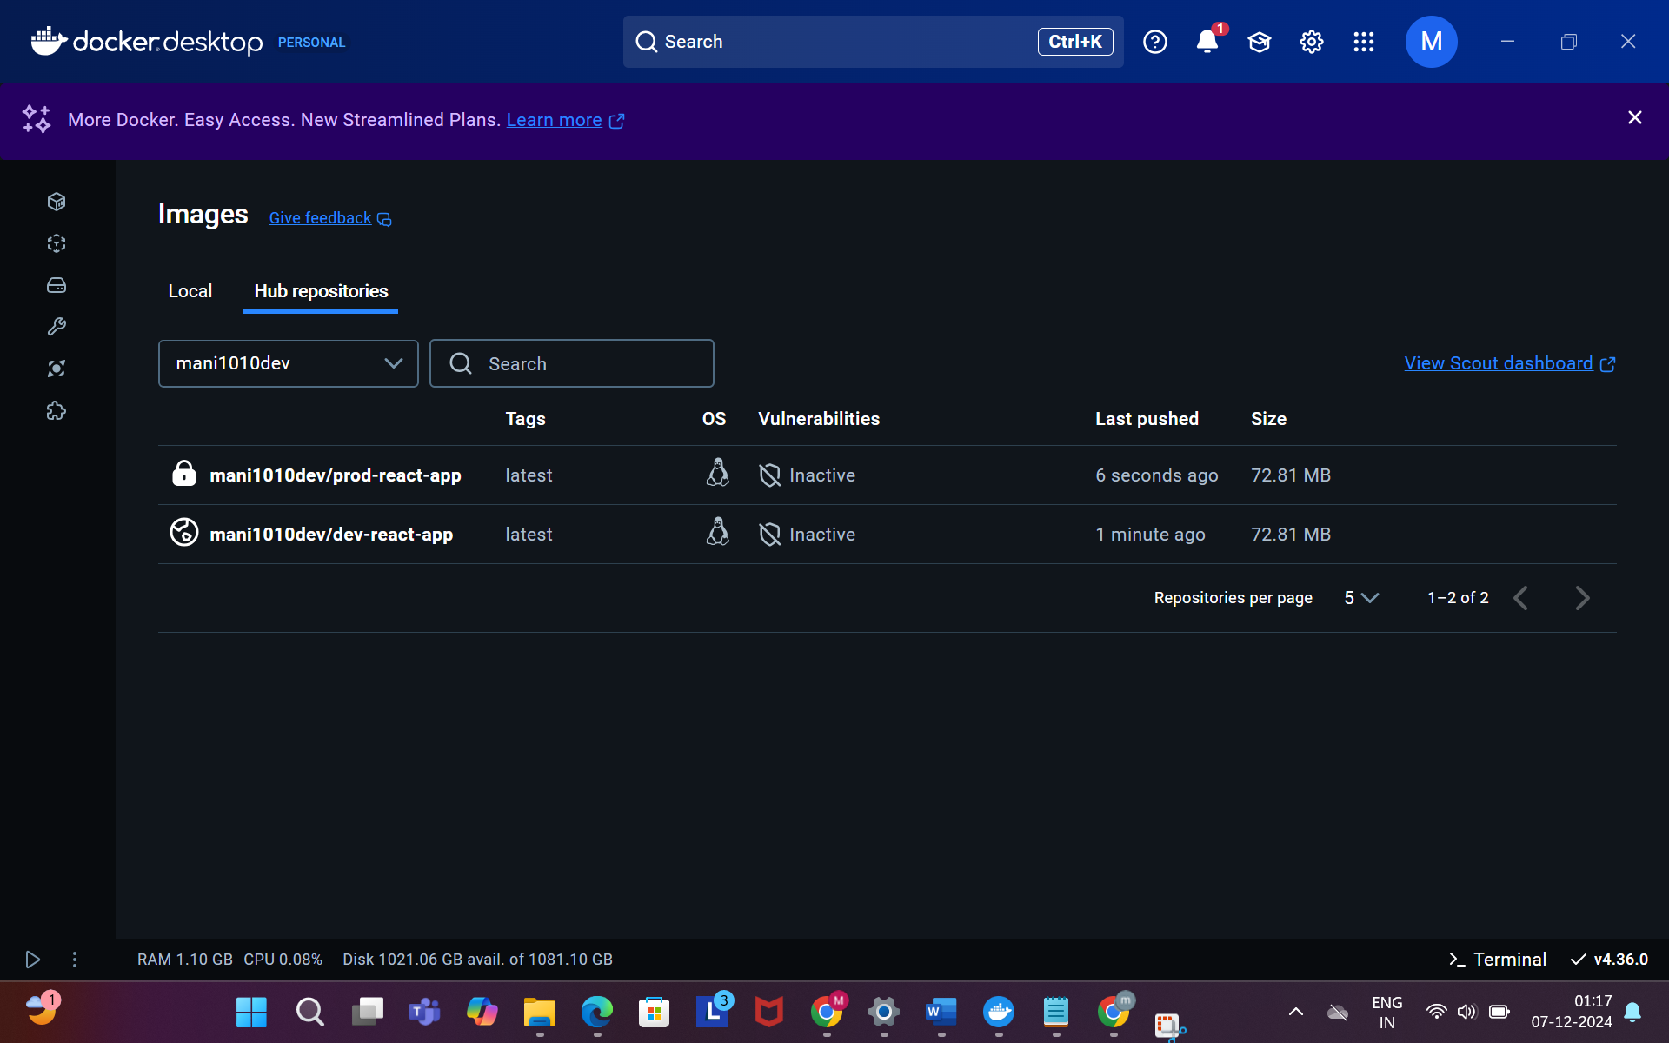

**Deployed site page**

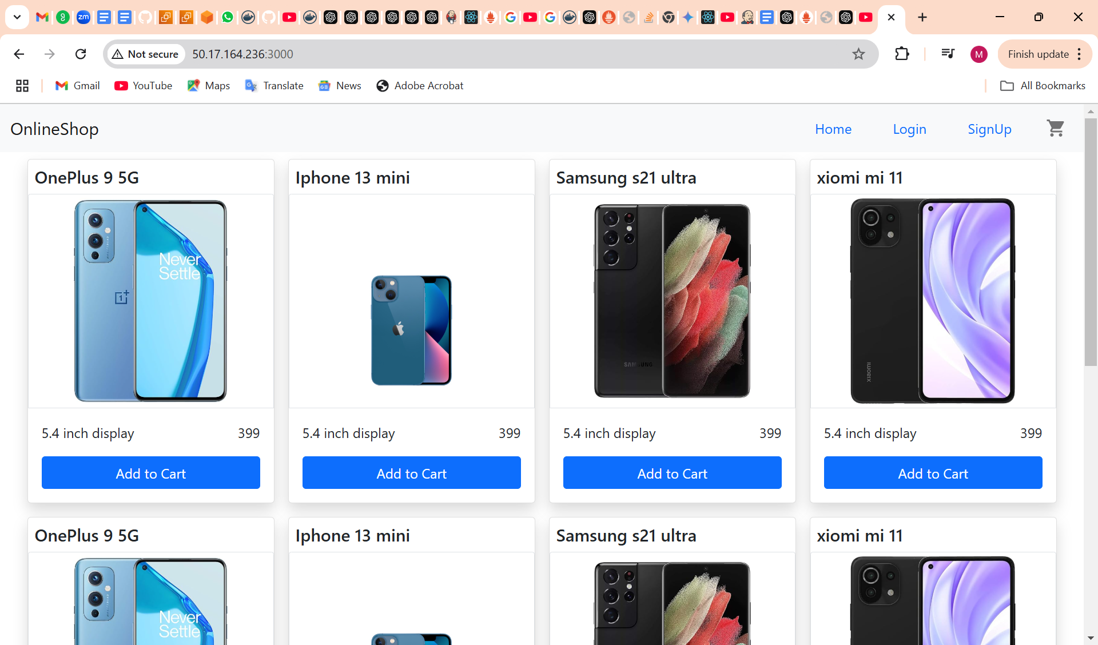

**Monitoring health check status**

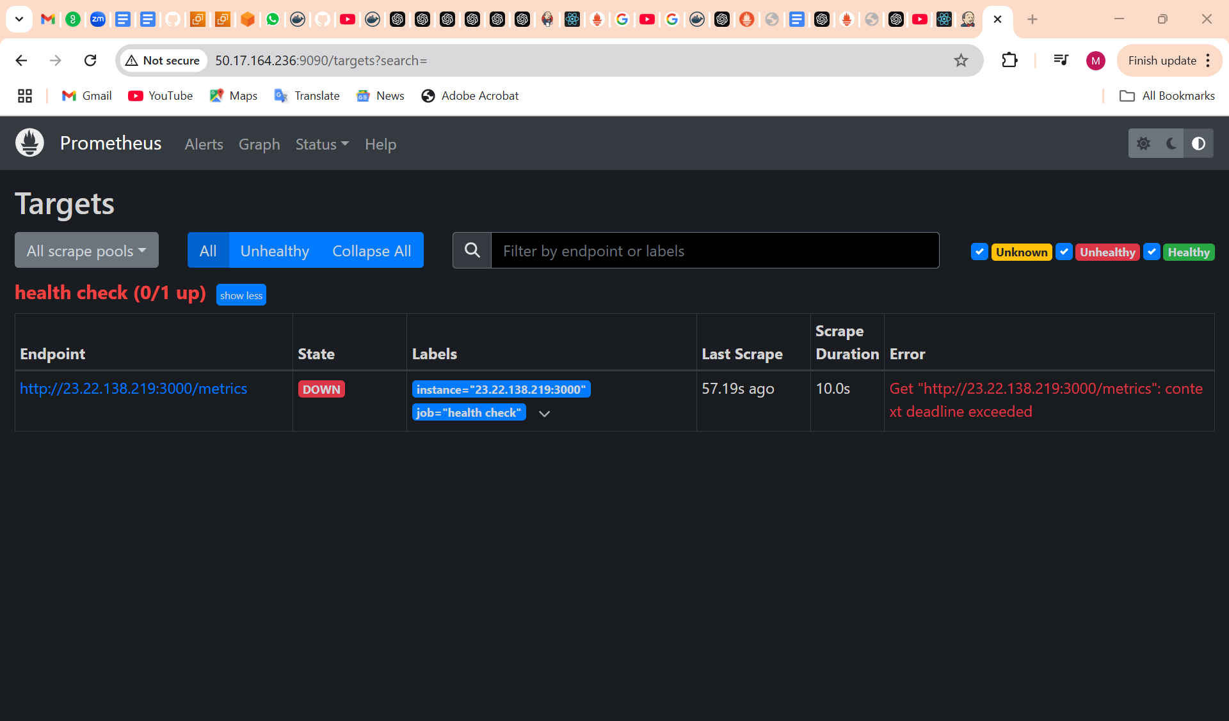

**GitHub Repo:**

